INTEGRATIVE COURSE IN PSYCHOLOGY (ICOPSYCH)

ANALYSIS ON THE RESULT OF POST-TEST EXAMINATION IN INDUSTRIAL PSYCHOLOGY
MARCH 22, 2025

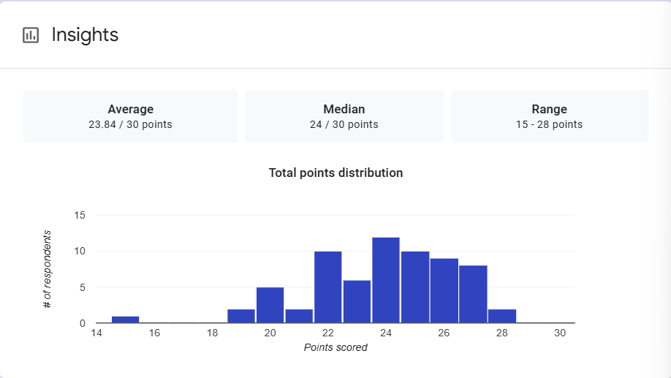

1. Mean Score: The mean (average) score is 23.84 out of 30, which suggests that, on average, participants performed fairly well on the exam. The mean is close to the maximum score (30), indicating that most students performed relatively well but there was some variation in scores.

2. Median Score: The median score is 24 out of 30, meaning that half of the participants scored above 24 and half scored below 24. This is a good indicator of central tendency because the median is less affected by extreme scores compared to the mean. The fact that the median is slightly higher than the mean suggests that there may be a few lower scores that are pulling the mean down, but overall, the majority of participants scored in the higher range.

3. Range: The range is 15 to 28 points, which shows the spread of scores from the lowest to the highest. This indicates a variation in exam performance, with the lowest score being 15 (a significantly lower score) and the highest score being 28 (still fairly high but not perfect). This suggests that while most participants performed relatively well, there were some outliers with lower scores.

Interpretation Summary:

-The data reveals that most participants performed well on the exam, with an average score close to 24 out of 30. The central tendency (mean and median) suggests that most scores clustered around the higher end of the scale.

-However, the range from 15 to 28 points indicates that there was some variability, with a few participants scoring lower.

-Overall, the results suggest generally strong performance, but with some room for improvement, especially among those on the lower end of the scale.

RATIONALIZATION:

DIFFICULT QUESTIONS:

